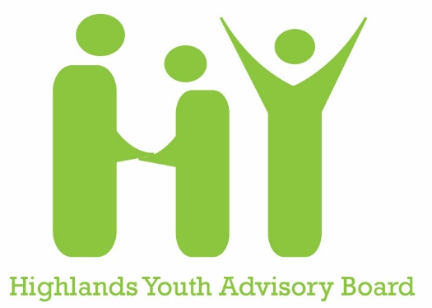
Application Questions

Note: Applications must be submitted online BY MAY 1 at
https://highlands-council.volunteerlocal.com/volunteer/?id=53622.
This document is to aid in preparing your answers to be entered on the form.

- Email Address
- First Name
- Last Name
- What is your birth date?
- In what grade will you be in Fall 2021?
- Where will you attend school in Fall 2021? (Name of school)
- What is your street address?
- What is your cell phone number (if you have one)?
- Do you use text messaging on that number?
- Please provide the name of a parent/guardian
- Parent/Guardian Cell Phone Number
- Parent/Guardian Email Address
- What social media platforms do you use?
- If you are selected for the HY Board, are you able to attend monthly meetings on Sunday afternoons? Y/N
- High Schoolers: If selected for the HY Board, will you commit to attending at least one weekday evening community board, committee, or city council meeting per quarter? Y/N

How did you learn about the HY Board and why are you interested in joining? If you have previously served on the HY Board, why are you interested in continuing for another year?

What do you hope to gain from your involvement on the HY Board? If you previously served on the HY Board, what have you gained from your involvement?

What talents and/or strengths would you share with the community through your involvement on the HY Board? If you previously served on the HY Board, what did you share during that time?

Please list any past and current community service and volunteer projects:

What other extracurricular commitments do you expect to have during the week and on weekends next school year? (sports, music dance, work, other activities, etc.)

What ideas do you have for HY Activities and projects for the year ahead?

What topics would you like to learn more about at HY Board meetings?

